This In Class Activity is due at the end of class today.

Student 1 name and ODIN id: __________________________________________

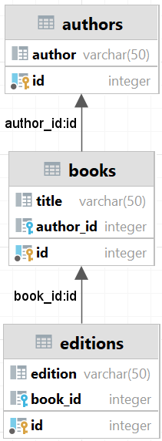
Using the following diagram and the file in Canvas (books2-inclass.sql), write select statements for the following questions. The following is a natural join between the authors and books tables. A natural join uses all column names that are common between the 2 tables as an inner join. Looking at the result set, what do you see as wrong with the results and why.
select a.author, b.title
from books2.authors as a
natural join books2.books as b
order by a.author, b.title;

- Write a query that joins the authors and books tables and shows correct authors and their books. Include a screen shot that shows the result set. Show only the author and title. Sort by author and title. There should be 4 rows.

- Modify the query from question 3 to show all the authors and their books (if they have any). Include a screen shot that shows the result set . There should be 6 rows.

- Modify the query from question 3 to show all the books and their authors (if they have any). Include a screen shot that shows the result set. There should be 7 rows.

- Modify the query from question 3 to show all the books and all the authors, matching author to book (if they have any) and book to author (if it has one). Include a screen shot that shows the result set. There should be 9 rows.

- Write a query that joins the authors, books, and editions table, that shows only authors with books and only books with editions. Show only the author, title, and edition. Sort by author, title, and edition. Include a screen shot that shows the result set . There should be 5 rows.

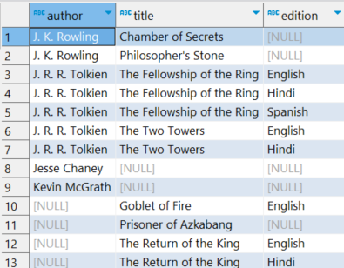
- Write a query that joins the authors, books, and editions table, that shows all authors, all books, and all editions. Some authors don’t have books. Some books don’t have editions. Match author to book (where there is an author) and match book to edition (where there is one). Show only the author, title, and edition. Sort by author, title, and edition. Include a screen shot that shows the result set. There should be 13 rows.

- Write a query that returns the Cartesian product of the authors and books tables. How many rows are in the result set?

